**Assignment-2**: Connect to the Private Server using the Bastion server using NAT Gateway

Step-1: Create a VPC

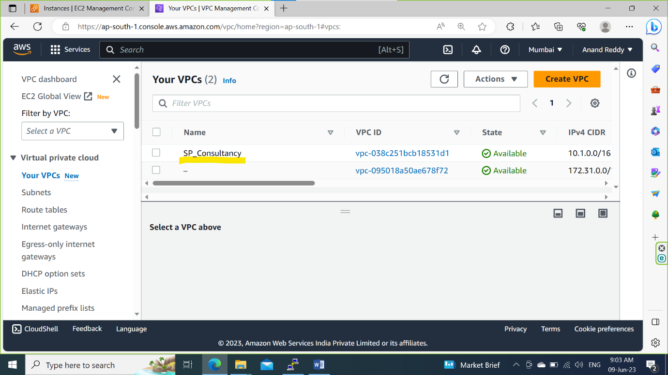

Step-2: Create a Subnets for Both Public and private.

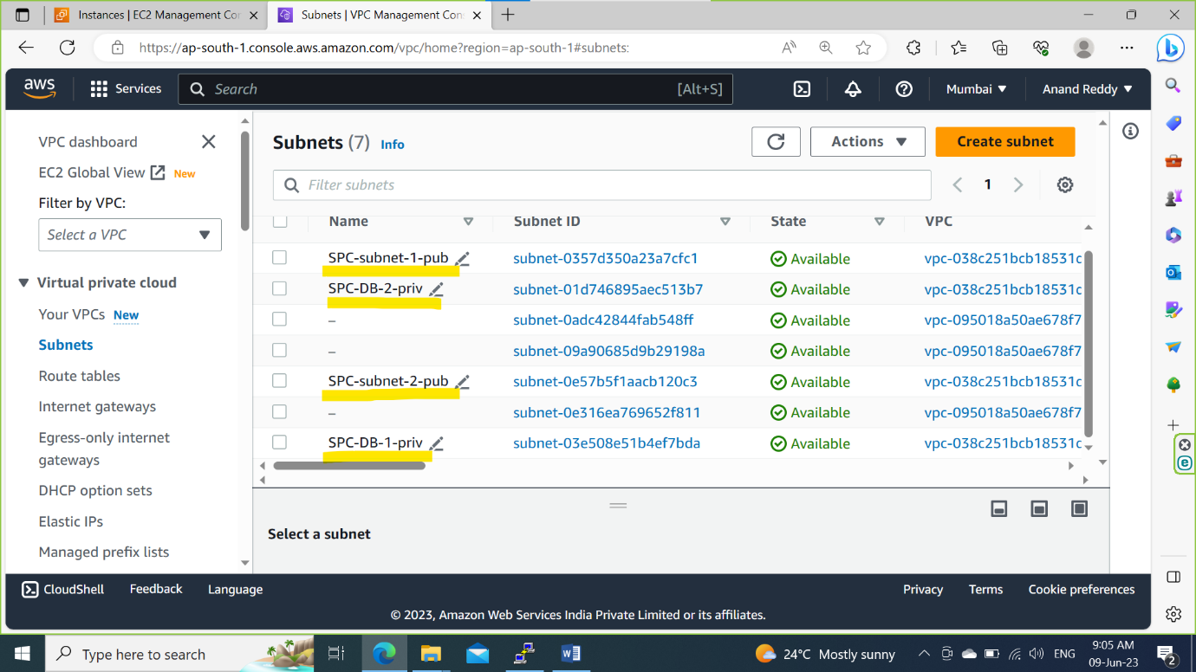

Step-3: Create a Internet Gateway name it as SPC-IGW and attach to the VPC.

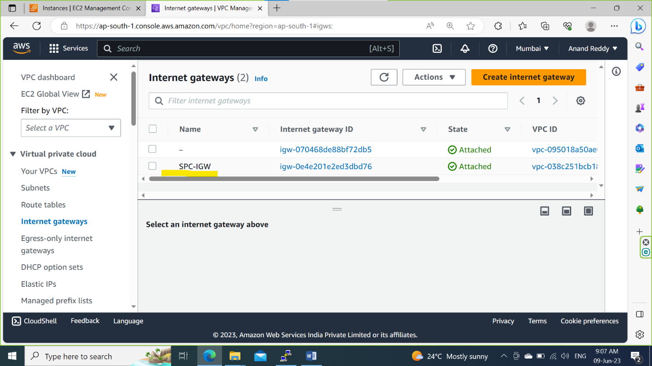

Step-4: Create a routing Table name it as SPC-MAIN-TABLE and attach Public Subnets to it.

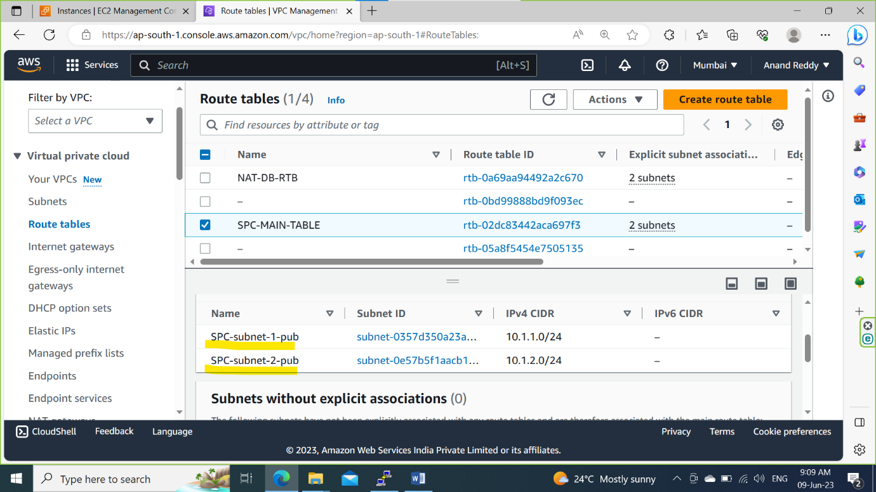

Step-5: Add a new route towards 0.0.0.0/0 through IGW.

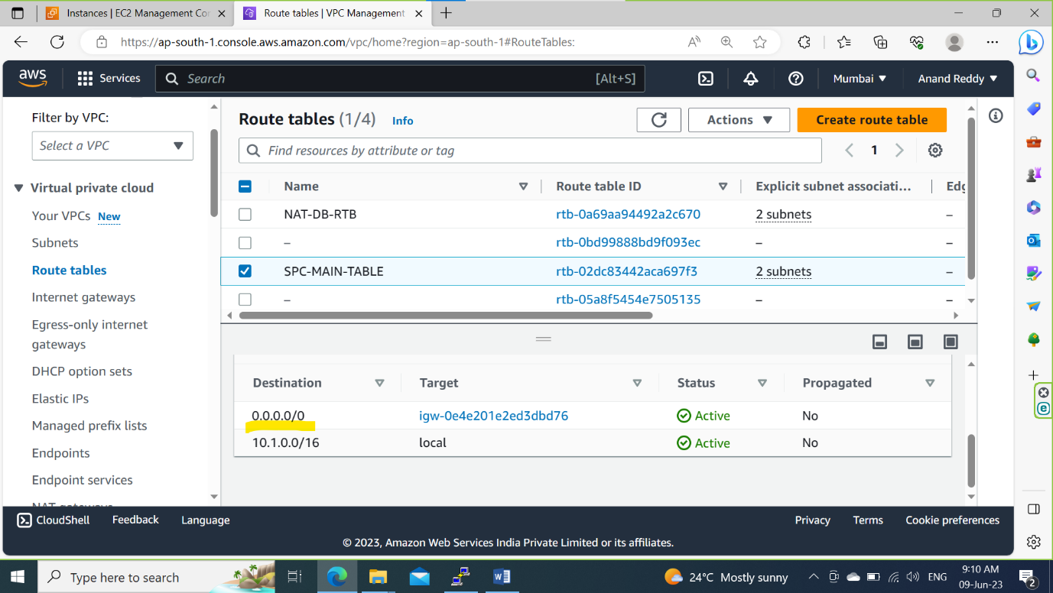

Step-6: Create a NAT Gate and select SPC-subnet1-pub and attach to VPC

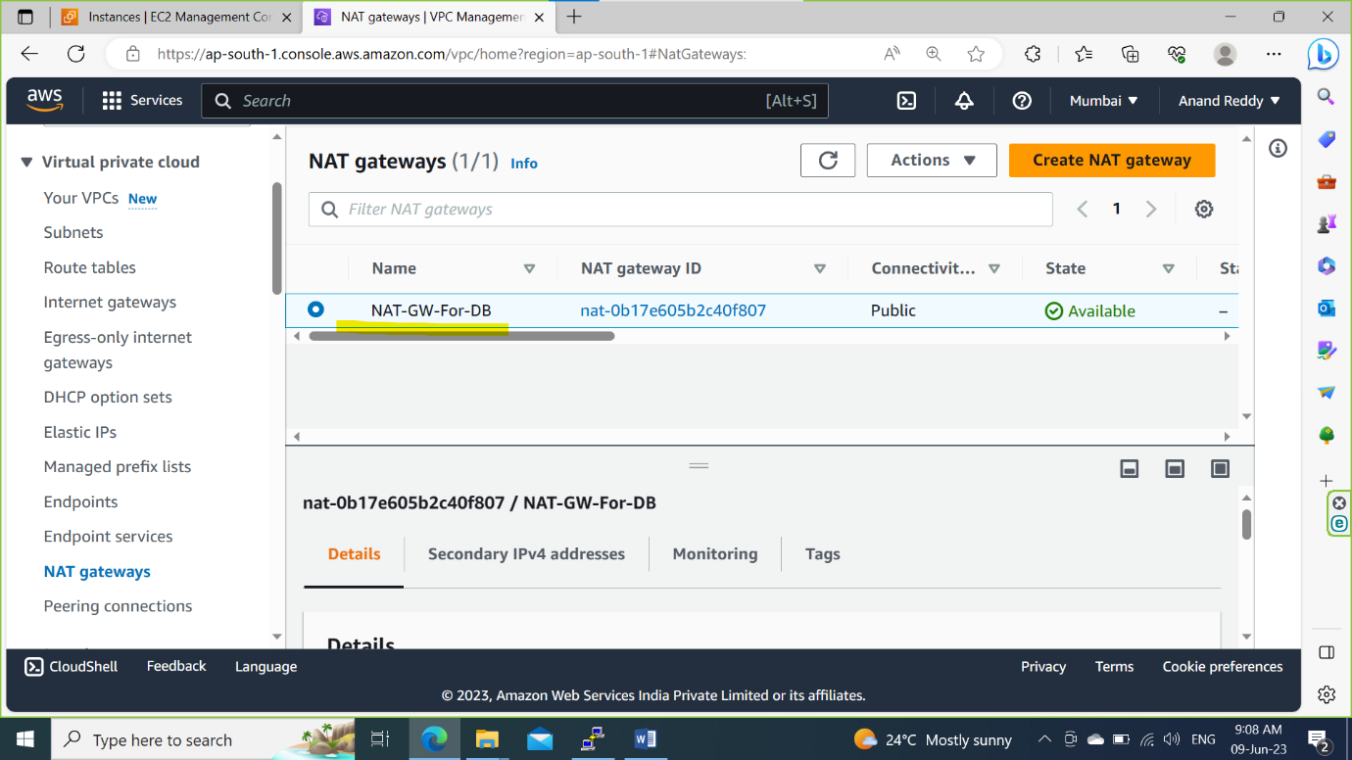

Step-7: Create a route table for NAT and attach private subnets to it.

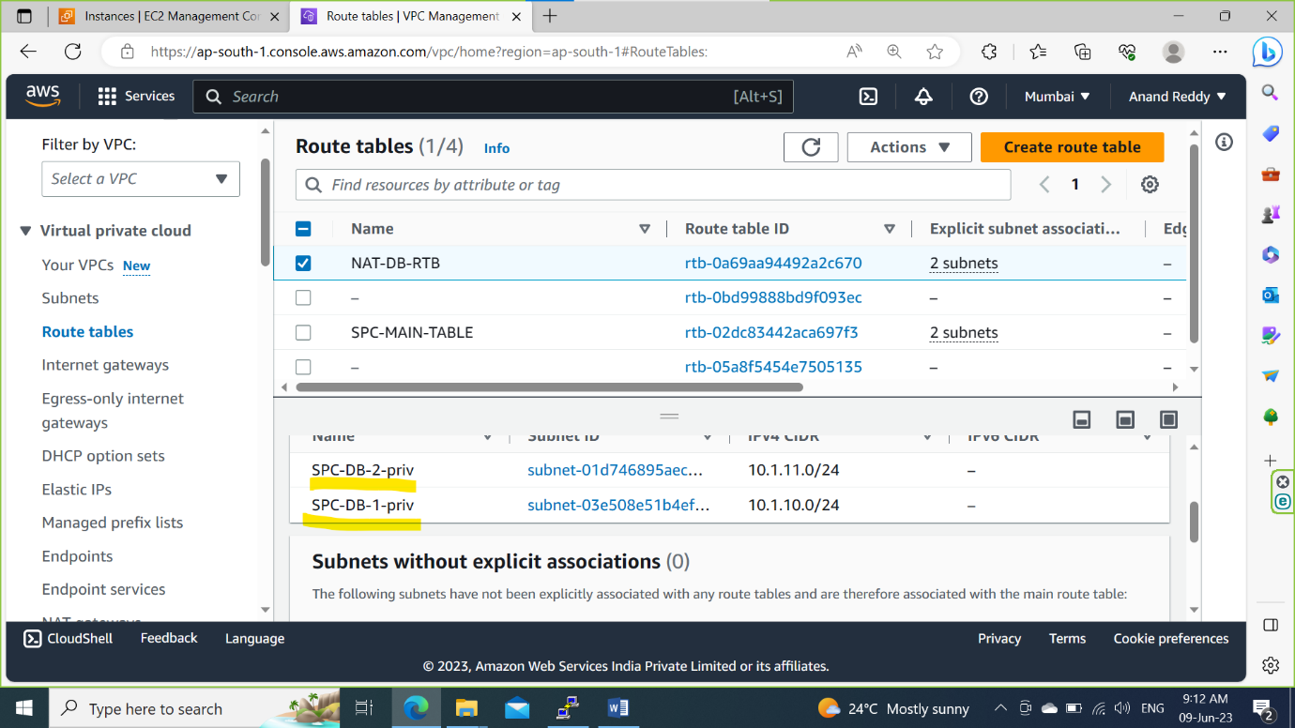

Step-8: Add a new route towards 0.0.0.0/0 through NAT Gateway

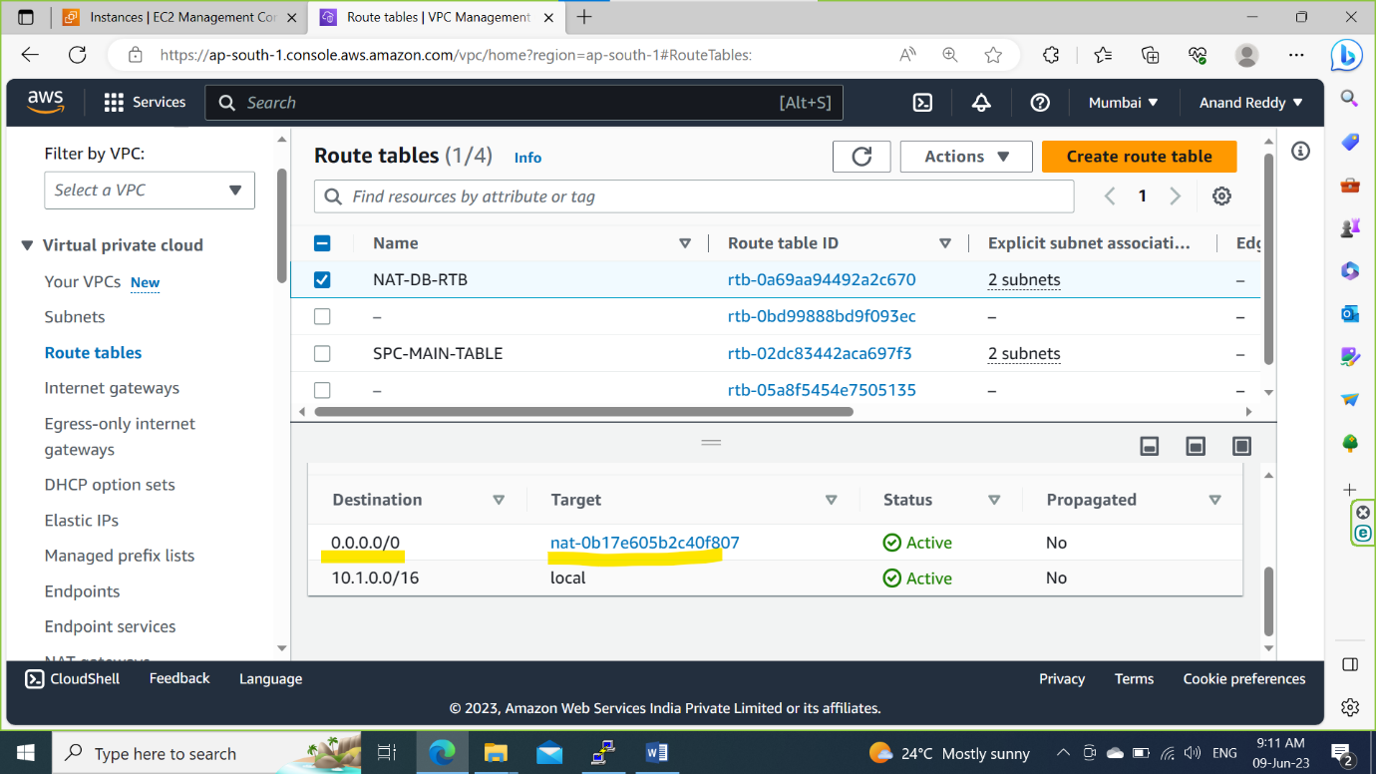

Step-9: Launch Public(Bastion Server) and Private(DB-priv) Server.

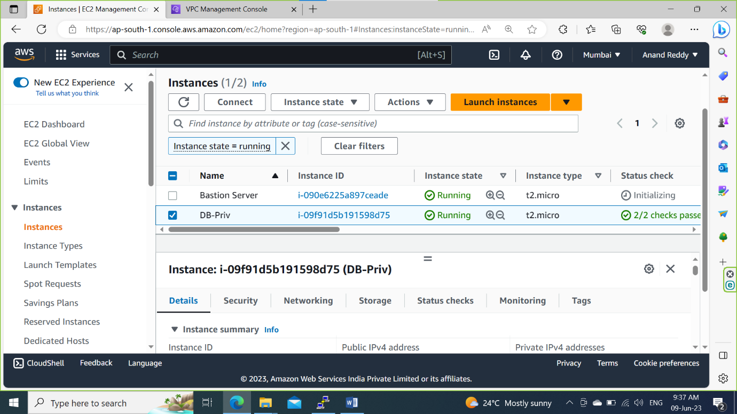

Step-10: Check the DB-priv server is pingable or not

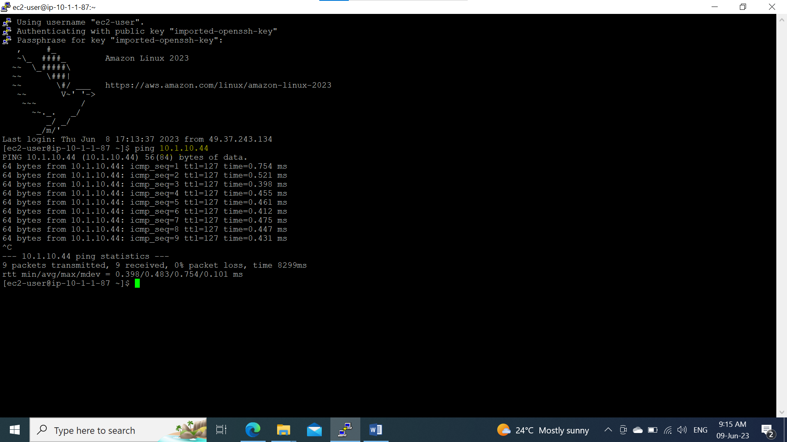

Step-11: Establish a Connection to DB-Server using SSH.

